Project Design Phase
Solution Architecture

Date | 02 October 2026
Team ID | SWTID-2026-6255
Project Name | AI FAQ Assistant API
Maximum Marks | 4 Marks
Team Size | 4
Team Leader | Dinesh. M
Team Members | Kalairajan. R, Sharan K, Sudharsan G

Solution Architecture:
Solution architecture is a complex process – with many sub-processes – that bridges the gap between business problems and technology solutions. Its goals are to:
- Find the best tech solution to solve existing business problems.
- Describe the structure, characteristics, behavior, and other aspects of the software to project stakeholders.
- Define features, development phases, and solution requirements.
- Provide specifications according to which the solution is defined, managed, and delivered.

Solution Architecture Diagram - AI FAQ Assistant API

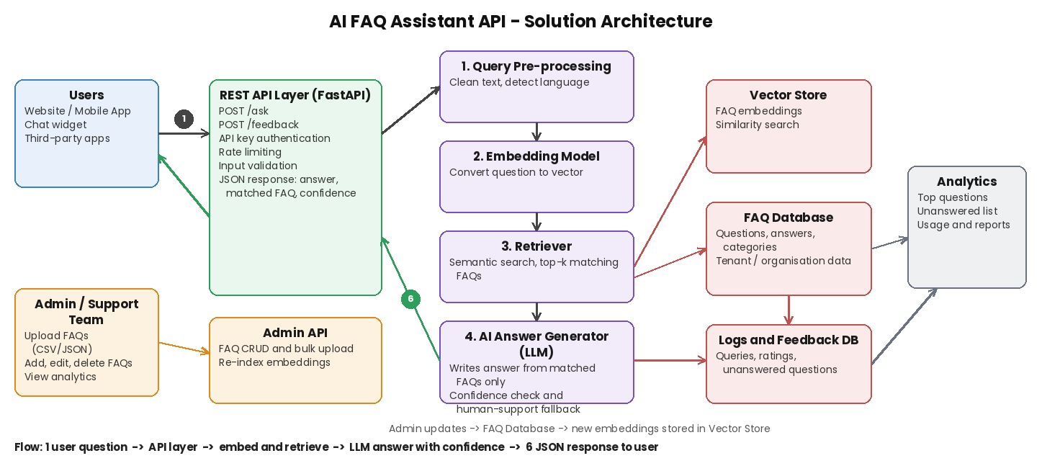
Figure 1: Architecture and data flow of the AI FAQ Assistant API
Reference: Architecture designed by Team SWTID-2026-6255 for the AI FAQ Assistant API

